


0,5% pari a € 26.871
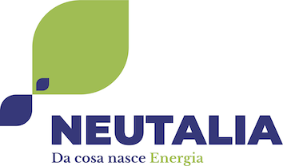
16,70% pari a € 553.478
15,28% pari a € 5.653.165

